

**Project Milestone**

Project Drive Safely

Guyana Police Agency

Names USI

Ibrahim Mohamed 1028696

Shamaar Huntley 1028670

Rudolph Adams 1026689

Enrique Ward 1026794

Ayancey Barker 1025287

Anthony Daly 1028513

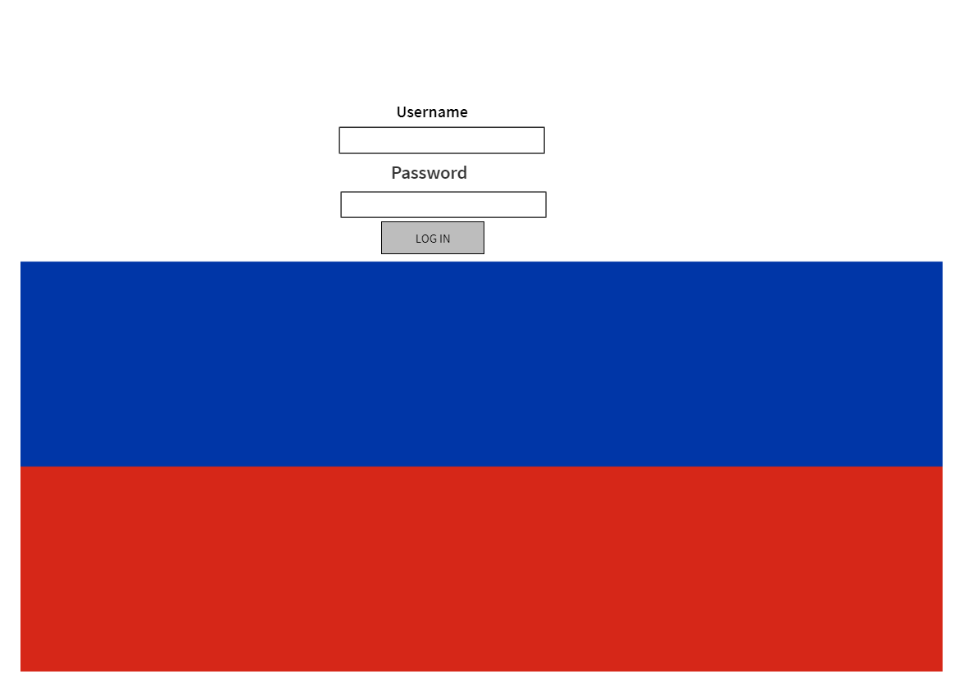**Mock up of Application Interface**

**Functional Requirements**

There shall be an initial page on the Web Site. This shall be the Home Page of the site. The Home page of the site shall contain the following controls:

* Login: This control shall spawn the login method.

The website will be able to connect to a WAMP database server. The Host Server shall contain definitions for user names, passwords and access roles, e.g. Administrator role, Manager role, User role and Guest role. These definitions shall be local to the Host Server only and shall be inaccessible from the Client in any form. The login method shall be displayed at the user location. The login shall succeed or fail. In case of a failure, a default authentication page shall be displayed depending on the reason it failed. The login shall be capable of cancellation. If cancelled the Home page shall be displayed. A login failure shall be displayed along with the login method with all fields blank. The password as entered shall display the character '*' in place of each password character entered.

When a user performs a successful login, a session shall begin and will not end until the user has logged out. The user shall be able to access the website anytime he wishes as long as he is still logged in. Additionally, a logout button will be made available. When clicked, the session will end and will be redirected to the homepage.